SAVITRIBAI PHULE PUNE UNIVERSITY

A PROJECT REPORT ON

PROJECT TITLE

SUBMITTED TOWARDS THE
PARTIAL FULFILLMENT OF THE REQUIREMENTS OF

BACHELOR OF ENGINEERING (Computer Engineering) BY
Student Name Exam No:
Student Name Exam No:
Student Name Exam No:
Student Name Exam No:

Under The Guidance of


Prof. Guide Name

DEPARTMENT OF COMPUTER ENGINEERING
College Name College Address

College Name
DEPARTMENT OF COMPUTER ENGINEERING

CERTIFICATE

This is to certify that the Project Entitled
PROJECT TITLE
Submitted by

Student Name Exam No:
Student Name Exam No:
Student Name Exam No:
Student Name Exam No:
is a bonafide work carried out by Students under the supervision of Prof. Guide Name and it is submitted towards the partial fulfillment of the requirement of Bach- elor of Engineering (Computer Engineering).
Prof. Guide Name Prof. HOD Name
Internal Guide H.O.D
Dept. of Computer Engg. Dept. of Computer Engg.
Dr. V. V. Dixit Principal
RMD Sinhgad School of Engineering

Signature of Internal Examiner Signature of External Examiner

PROJECT APPROVAL SHEET

A Project Title (Project Title)
Is successfully completed by

Student Name Exam No:
Student Name Exam No:
Student Name Exam No:
Student Name Exam No: at
DEPARTMENT OF COMPUTER ENGINEERING (COLLEGE NAME)
SAVITRIBAI PHULE PUNE UNIVERSITY,PUNE ACADEMIC YEAR 2019-2020

Prof. Guide Name Prof. HOD Name
Internal Guide H.O.D
Dept. of Computer Engg. Dept. of Computer Engg.

Abstract

Please Write here One Page Abstract. It should mainly include introduction, moti- vation,outcome and innovation if any.

Acknowledgments

Please Write here Acknowledgment.Example given as
It gives us great pleasure in presenting the preliminary project report on ‘BE PROJECT TITLE’.

I would like to take this opportunity to thank my internal guide Prof. Guide Name for giving me all the help and guidance I needed. I am really grateful to them for their kind support. Their valuable suggestions were very helpful.

I am also grateful to Prof. HOD Name, Head of Computer Engineering Department, CollegeName for his indispensable support, suggestions.

In the end our special thanks to Other Person Name for providing various resources such as laboratory with all needed software platforms, continuous Internet connec- tion, for Our Project.

Student Name1 Student Name2 Student Name3 Student Name4
(B.E. Computer Engg.)

INDEX

- Synopsis 1
  - Project Title . . . . . . . . . . . . . . . . . . . . . . . . . . . . . . 2
  - Project Option . . . . . . . . . . . . . . . . . . . . . . . . . . . . 2
  - Internal Guide . . . . . . . . . . . . . . . . . . . . . . . . . . . . . 2
  - Sponsorship and External Guide . . . . . . . . . . . . . . . . . . . 2
  - Technical Keywords (As per ACM Keywords) . . . . . . . . . . . . 2
  - Problem Statement . . . . . . . . . . . . . . . . . . . . . . . . . . 2
  - Abstract . . . . . . . . . . . . . . . . . . . . . . . . . . . . . . . . 3
  - Goals and Objectives . . . . . . . . . . . . . . . . . . . . . . . . . 3
  - Relevant mathematics associated with the Project . . . . . . . . . . 3
  - Names of Conferences / Journals where papers can be published . . 3
  - Review of Conference/Journal Papers supporting Project idea . . . . 4
  - Plan of Project Execution . . . . . . . . . . . . . . . . . . . . . . . 4
- Technical Keywords 5
  - Area of Project . . . . . . . . . . . . . . . . . . . . . . . . . . . . 6
  - Technical Keywords . . . . . . . . . . . . . . . . . . . . . . . . . . 6
- Introduction 7
  - Project Idea . . . . . . . . . . . . . . . . . . . . . . . . . . . . . . 8
  - Motivation of the Project . . . . . . . . . . . . . . . . . . . . . . . 8
  - Literature Survey . . . . . . . . . . . . . . . . . . . . . . . . . . . 8
- Problem Definition and scope 9
  - Problem Statement 10
    - Goals and objectives 10
    - Statement of scope 10
  - Major Constraints 10
  - Methodologies of Problem solving and efficiency issues 10
  - Outcome 10
  - Applications 11
  - Hardware Resources Required 11
  - Software Resources Required 11
- Project Plan 12
  - Project Estimates 13
    - Reconciled Estimates 13
    - Project Resources 13
  - Risk Management w.r.t. NPHard analysis 13
    - Risk Identification 13
    - Risk Analysis 14
    - Overview of Risk Mitigation, Monitoring, Management 15
  - Project Schedule 15
    - Project task set 15
    - Task network 16
    - Timeline Chart 16
  - Team Organization 16
    - Team structure 16
    - Management reporting and communication 16
- Software requirement specification 17
  - Introduction 18
    - Purpose and Scope of Document 18
    - Overview of responsibilities of Developer 18
  - Usage Scenario 18

6.2.1 | User profiles | 18
6.2.2 | Use-cases | 18

 | 6.2.3 | Use Case View . . . . . . . . . . . . . . . . . . . . . . . . | 18
6.3 | Data | Model and Description . . . . . . . . . . . . . . . . . . . . . | 19
 | 6.3.1 | Data Description . . . . . . . . . . . . . . . . . . . . . . . | 19
 | 6.3.2 | Data objects and Relationships . . . . . . . . . . . . . . . . | 19
  - Functional Model and Description 19
    - Data Flow Diagram 20
    - Activity Diagram 20
    - Non Functional Requirements 20
    - State Diagram: 20
    - Design Constraints 20
    - Software Interface Description 20
- Detailed Design Document using Appendix A and B 22
  - Introduction 23
  - Architectural Design 23
  - Data design (using Appendices A and B) 23
    - Internal software data structure 23
    - Global data structure 24
    - Temporary data structure 24
    - Database description 24
  - Compoent Design 24
    - Class Diagram 24
- Project Implementation 26
  - Introduction 27
  - Tools and Technologies Used 27
  - Methodologies/Algorithm Details 27
    - Algorithm 1/Pseudo Code 27
    - Algorithm 2/Pseudo Code 27
  - Verification and Validation for Acceptance 27
- Software Testing 28
  - Type of Testing Used 29

  - Test Cases and Test Results 29
- Results 30
  - Screen shots 31
  - Outputs 31
- Deployment and Maintenance 32
  - Installation and un-installation 33
  - User help 33
- Conclusion and future scope 34
Annexure A References 36
Annexure B Project Planner 37
Annexure C Reviewers Comments of Paper Submitted 38
Annexure D Plagiarism Report 39
Annexure E Information of Project Group Members 40

List of Figures

  - Use case diagram 19
  - State transition diagram 21

  - Architecture diagram 23
  - Class Diagram 25

List of Tables

4.1 | Hardware Requirements . . . . . . . . . . . . . . . . . . . . . . . | 11
5.1 | Risk Table . . . . . . . . . . . . . . . . . . . . . . . . . . . . . . . | 14
5.2 | Risk Probability definitions [?] . . . . . . . . . . . . . . . . . . . . | 14
5.3 | Risk Impact definitions [?] . . . . . . . . . . . . . . . . . . . . . . | 14
6.1 | Use Cases . . . . . . . . . . . . . . . . . . . . . . . . . . . . . . . | 18
B.1 | IDEA Matrix . . . . . . . . . . . . . . . . . . . . . . . . . . . . . | 37

CHAPTER 1 SYNOPSIS

PROJECT TITLE

Project Title

PROJECT OPTION

Please mention type either industry sponsored, entrepreneur or internal project

INTERNAL GUIDE

Prof. Internal Guide Name

SPONSORSHIP AND EXTERNAL GUIDE

Please write if any sponsorship

TECHNICAL KEYWORDS (AS PER ACM KEYWORDS)

Please note ACM Keywords can be found : http://www.acm.org/about/class/ccs98- html
Example is given as
    - C. Computer Systems Organization

      - C.2 COMPUTER-COMMUNICATION NETWORKS
        - C.2.4 Distributed Systems
          - Client/server
          - Distributed applications
          - Distributed databases
          - Network operating systems
          - Distributed file systems
          - Security and reliability issues in distributed applications

PROBLEM STATEMENT

Define Problem Statement

ABSTRACT

- Abstract (10 to 15 lines)

GOALS AND OBJECTIVES

- Objectives

RELEVANT MATHEMATICS ASSOCIATED WITH THE PROJECT

System Description:

- Input:

- Output:

- Identify data structures, classes, divide and conquer strategies to exploit dis- tributed/parallel/concurrent processing, constraints.
- Functions : Identify Objects, Morphisms, Overloading in functions, Func- tional relations
- Mathematical formulation if possible

- Success Conditions:

- Failure Conditions:

NAMES OF CONFERENCES / JOURNALS WHERE PAPERS CAN BE PUBLISHED
- IEEE/ACM Conference/Journal 1

- Conferences/workshops in IITs

- Central Universities or SPPU Conferences

- IEEE/ACM Conference/Journal 2

REVIEW OF CONFERENCE/JOURNAL PAPERS SUPPORTING PROJECT IDEA
Atleast 10 papers + White papers or web references
Brief literature survey [ Description containing important description of at least 10 papers

PLAN OF PROJECT EXECUTION

Using planner or alike project management tool.

CHAPTER 2 TECHNICAL KEYWORDS

AREA OF PROJECT

Project Area

TECHNICAL KEYWORDS

Please note ACM Keywords can be found : http://www.acm.org/about/class/ccs98- html
Example is given as

    - C. Computer Systems Organization

      - C.2 COMPUTER-COMMUNICATION NETWORKS
        - C.2.4 Distributed Systems
          - Client/server
          - Distributed applications
          - Distributed databases
          - Network operating systems
          - Distributed file systems
          - Security and reliability issues in distributed applications

CHAPTER 3 INTRODUCTION

PROJECT IDEA

    - Project Idea

MOTIVATION OF THE PROJECT

    - Motivation of the Project

LITERATURE SURVEY

    - Review of the papers, Description , Mathematical Terms

CHAPTER 4

PROBLEM DEFINITION AND SCOPE

PROBLEM STATEMENT

Description of Problem

Goals and objectives

Goal and Objectives:

      - Overall goals and objectives of software, input and output description with necessary syntax, format etc are described

Statement of scope

      - A description of the software with Size of input, bounds on input, input val- idation, input dependency, i/o state diagram, Major inputs, and outputs are described without regard to implementation detail.
      - The scope identifies what the product is and is not, what it will and wont do, what it will and wont contain.

MAJOR CONSTRAINTS

- Any constraints that will impact the manner in which the software is to be specified, designed, implemented or tested are noted here.

METHODOLOGIES OF PROBLEM SOLVING AND EFFICIENCY IS- SUES
- The single problem can be solved by different solutions. This considers the performance parameters for each approach. Thus considers the efficiency is- sues.

OUTCOME

- Outcome of the project

APPLICATIONS

- Applications of Project

HARDWARE RESOURCES REQUIRED

Sr. No. | Parameter | Minimum Requirement | Justification
1 | CPU Speed | 2 GHz | Remark Required
2 | RAM | 3 GB | Remark Required
Table 4.1: Hardware Requirements

SOFTWARE RESOURCES REQUIRED

Platform :

- Operating System:

- IDE:

- Programming Language

CHAPTER 5 PROJECT PLAN

PROJECT ESTIMATES

Use Waterfall model and associated streams derived from assignments 1,2, 3, 4 and 5( Annex A and B) for estimation.

Reconciled Estimates

      - Cost Estimate

      - Time Estimates

Project Resources

Project resources [People, Hardware, Software, Tools and other resources] based on Memory Sharing, IPC, and Concurrency derived using appendices to be referred.

RISK MANAGEMENT W.R.T. NP HARD ANALYSIS

This section discusses Project risks and the approach to managing them.

Risk Identification

For risks identification, review of scope document, requirements specifications and schedule is done. Answers to questionnaire revealed some risks. Each risk is cate- gorized as per the categories mentioned in [?]. Please refer table 5.1 for all the risks. You can refereed following risk identification questionnaire.
- Have top software and customer managers formally committed to support the project?
- Are end-users enthusiastically committed to the project and the system/product to be built?
- Are requirements fully understood by the software engineering team and its customers?
- Have customers been involved fully in the definition of requirements?

- Do end-users have realistic expectations?

- Does the software engineering team have the right mix of skills?

- Are project requirements stable?

- Is the number of people on the project team adequate to do the job?

- Do all customer/user constituencies agree on the importance of the project and on the requirements for the system/product to be built?

Risk Analysis

The risks for the Project can be analyzed within the constraints of time and quality

ID | Risk Description | Probability | Impact
 |  |  | Schedule | Quality | Overall
1 | Description 1 | Low | Low | High | High
2 | Description 2 | Low | Low | High | High

Table 5.1: Risk Table

Probability | Value | Description
High | Probability of occurrence is | > 75%
Medium | Probability of occurrence is | 26 − 75%
Low | Probability of occurrence is | < 25%

Table 5.2: Risk Probability definitions [?]

Impact | Value | Description
Very high | > 10% | Schedule impact or Unacceptable quality
High | 5 − 10% | Schedule impact or Some parts of the project have low quality
Medium | < 5% | Schedule impact or Barely noticeable degradation in qual- ity Low Impact on schedule or Quality can be incorporated

Table 5.3: Risk Impact definitions [?]

Overview of Risk Mitigation, Monitoring, Management

Following are the details for each risk.

Risk ID | 1
Risk Description | Description 1
Category | Development Environment.
Source | Software requirement Specification document.
Probability | Low
Impact | High
Response | Mitigate
Strategy | Strategy
Risk Status | Occurred

Risk ID | 2
Risk Description | Description 2
Category | Requirements
Source | Software Design Specification documentation review.
Probability | Low
Impact | High
Response | Mitigate
Strategy | Better testing will resolve this issue.
Risk Status | Identified

PROJECT SCHEDULE

Project task set

Major Tasks in the Project stages are:

- Task 1:

- Task 2:

- Task 3:

Risk ID | 3
Risk Description | Description 3
Category | Technology
Source | This was identified during early development and testing.
Probability | Low
Impact | Very High
Response | Accept
Strategy | Example Running Service Registry behind proxy balancer
Risk Status | Identified

- Task 4:

- Task 5:

Task network

Project tasks and their dependencies are noted in this diagrammatic form.

Timeline Chart

A project timeline chart is presented. This may include a time line for the entire project. Above points should be covered in Project Planner as Annex C and you can mention here Please refer Annex C for the planner

TEAM ORGANIZATION

The manner in which staff is organized and the mechanisms for reporting are noted.

Team structure

The team structure for the project is identified. Roles are defined.

Management reporting and communication

Mechanisms for progress reporting and inter/intra team communication are identi- fied as per assessment sheet and lab time table.

CHAPTER 6 SOFTWARE REQUIREMENT
SPECIFICATION

INTRODUCTION

Purpose and Scope of Document

The purpose of SRS and what it covers is to be stated

Overview of responsibilities of Developer

What all activities carried out by developer?

USAGE SCENARIO

This section provides various usage scenarios for the system to be developed.

User profiles

The profiles of all user categories are described here.(Actors and their Description)

Use-cases

All use-cases for the software are presented. Description of all main Use cases using use case template is to be provided.
Sr No. | Use Case | Description | Actors | Assumptions
1 | Use Case 1 | Description | Actors | Assumption

Table 6.1: Use Cases

Use Case View

Use Case Diagram. Example is given below

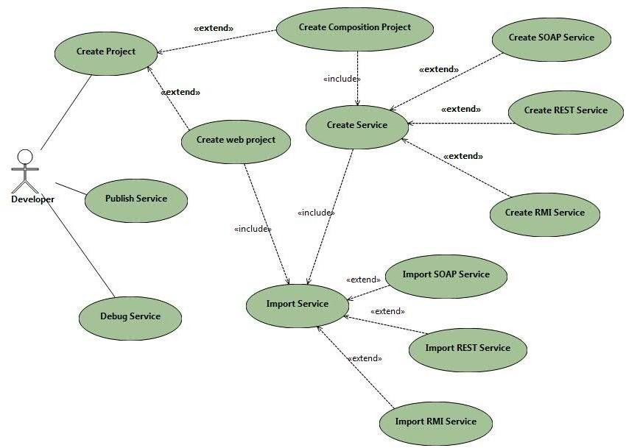
Figure 6.1: Use case diagram

DATA MODEL AND DESCRIPTION

Data Description

Data objects that will be managed/manipulated by the software are described in this section. The database entities or files or data structures required to be described. For data objects details can be given as below

Data objects and Relationships

Data objects and their major attributes and relationships among data objects are de- scribed using an ERD- like form.

FUNCTIONAL MODEL AND DESCRIPTION

A description of each major software function, along with data flow (structured anal- ysis) or class hierarchy (Analysis Class diagram with class description for object oriented system) is presented.

Data Flow Diagram

      - Level 0 Data Flow Diagram

      - Level 1 Data Flow Diagram

Activity Diagram:

- The Activity diagram represents the steps taken.

Non Functional Requirements:

- Interface Requirements

- Performance Requirements

- Software quality attributes such as availability [ related to Reliability], modi- fiability [includes portability, reusability, scalability] , performance, security, testability and usability[includes self adaptability and user adaptability]

State Diagram:

State Transition Diagram
Fig.6.2 example shows the state transition diagram of Cloud SDK. The states are represented in ovals and state of system gets changed when certain events occur. The transitions from one state to the other are represented by arrows. The Figure shows important states and events that occur while creating new project.

Design Constraints

Any design constraints that will impact the subsystem are noted.

Software Interface Description

The software interface(s)to the outside world is(are) described. The requirements for interfaces to other devices/systems/networks/human are stated.

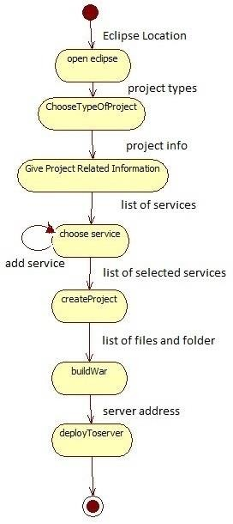
Figure 6.2: State transition diagram

CHAPTER 7

DETAILED DESIGN DOCUMENT USING APPENDIX A AND B

INTRODUCTION

This document specifies the design that is used to solve the problem of Product.

ARCHITECTURAL DESIGN

A description of the program architecture is presented. Subsystem design or Block diagram,Package Diagram,Deployment diagram with description is to be presented.
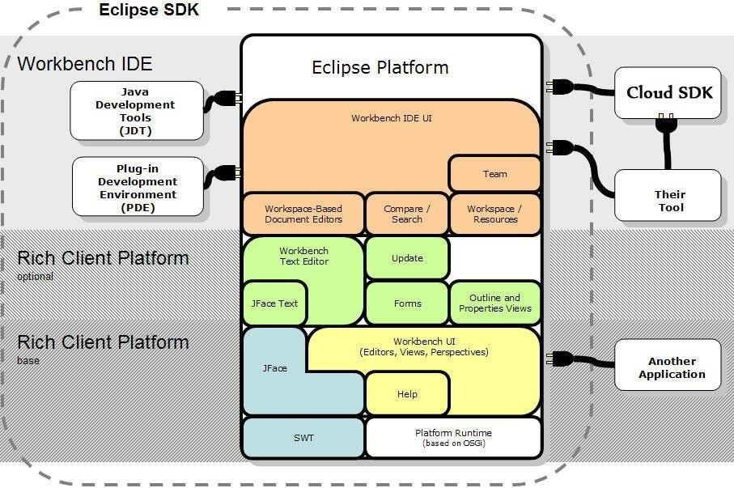
Figure 7.1: Architecture diagram

DATA DESIGN (USING APPENDICES A AND B)

A description of all data structures including internal, global, and temporary data structures, database design (tables), file formats.

Internal software data structure

Data structures that are passed among components the software are described.

Global data structure

Data structured that are available to major portions of the architecture are described.

Temporary data structure

Files created for interim use are described.

Database description

Database(s) / Files created/used as part of the application is(are) described.

COMPOENT DESIGN

Class diagrams, Interaction Diagrams, Algorithms. Description of each component description required.

Class Diagram

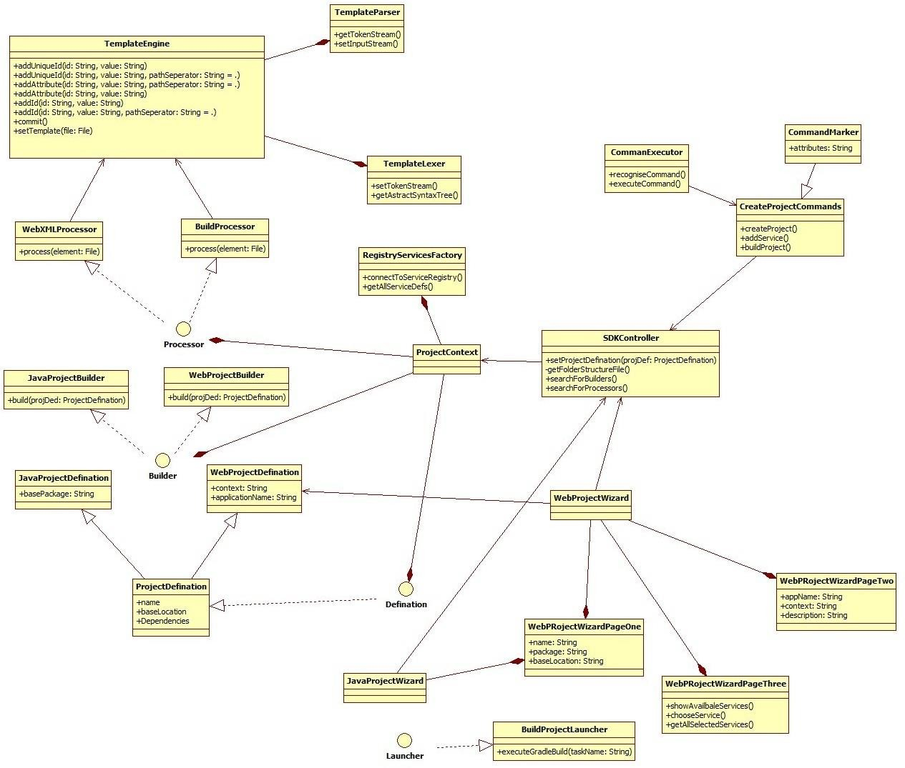

Figure 7.2: Class Diagram

CHAPTER 8 PROJECT IMPLEMENTATION

INTRODUCTION

TOOLS AND TECHNOLOGIES USED

METHODOLOGIES/ALGORITHM DETAILS

Algorithm 1/Pseudo Code

Algorithm 2/Pseudo Code

VERIFICATION AND VALIDATION FOR ACCEPTANCE

CHAPTER 9 SOFTWARE TESTING

TYPE OF TESTING USED

Unit,Integration,system etc.

TEST CASES AND TEST RESULTS

for each type of testing done.

CHAPTER 10 RESULTS

SCREEN SHOTS

Outputs / Snap shots of the results

OUTPUTS

Outputs / Snap shots of the results

CHAPTER 11 DEPLOYMENT AND MAINTENANCE

INSTALLATION AND UN-INSTALLATION

USER HELP

CHAPTER 12 CONCLUSION AND FUTURE SCOPE

Write summary , conclusion and future scope

ANNEXURE A REFERENCES

(Strictly in ACM Format)

ANNEXURE B PROJECT PLANNER

Using planner or alike project management tool.

ANNEXURE C REVIEWERS COMMENTS OF PAPER
SUBMITTED

(At-least one technical paper must be submitted in Term-I on the project design in the conferences/workshops in IITs, Central Universities or UoP Conferences or equivalent International Conferences Sponsored by IEEE/ACM)
    - Paper Title:

    - Name of the Conference/Journal where paper submitted :

    - Paper accepted/rejected :

    - Review comments by reviewer :

    - Corrective actions if any :

ANNEXURE D PLAGIARISM REPORT

Plagiarism report

ANNEXURE E INFORMATION OF PROJECT GROUP
MEMBERS

one page for each student .

- Name :

photo.jpg

- Date of Birth :

- Gender :

- Permanent Address :

- E-Mail :

- Mobile/Contact No. :

- Placement Details :

- Paper Published :

